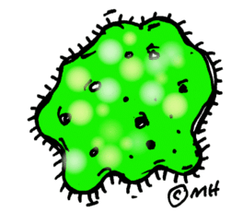
Healthy Gut : Pre- and Pro- Biotics

Probiotics and prebiotics are components present in foods, or that can be incorporated into foods, which yield health benefits related to their interactions with the gastrointestinal tract (GI). While the benefits of prebiotics have come to light in more recent years, recognition of probiotic effects dates back to the 19th century when the French scientist Louis Pasteur postulated the importance of microorganisms in human life.

A probiotic has been defined as “a live microbial food ingredient that, when ingested in sufficient quantities, exerts health benefits.” Probiotic microorganisms can be found in both supplement form and as components of foods and beverages. These bacteria and yeasts have been used for thousands of years to ferment foods. Certain yogurts and other cultured dairy products contain such helpful bacteria, particularly specific strains of Bifidobacteria and Lactobacilli.

Prebiotics are found naturally in many foods, and can also be isolated from plants or synthesized. In order for a food ingredient to be classified as a prebiotic, it has to be demonstrated, that it: (a) is not broken down in the stomach or absorbed in the GI tract, (b) is fermented by the gastrointestinal microflora; and (c) most importantly, selectively stimulates the growth and/or activity of intestinal bacteria associated with health and wellbeing.

Probiotic bacteria taken together with prebiotics that support their growth are called “synbiotics.” Both work together in a synergistic way more efficiently promoting the probiotics’ benefits.
The human gastrointestinal environment, including the microflora, has a significant role in the health of its host. The normal gut microflora activity is complex and can be impacted by a number of factors. The gut microflora, which includes both potentially beneficial and potentially harmful bacteria, is important in maintaining a healthy intestinal tract and helps the intestine act as an effective barrier; allowing nutrients to be absorbed, and keeping out toxins and pathogens (foreign bacteria or viruses).

Consumption of probiotics, particularly certain species of Bifidobacteria and Lactobacilli, can help “balance” the flora, increasing the number of helpful, and inhibiting the growth of harmful bacteria, in the intestine. Consumption of probiotics can also modify the gut immune response and improve its barrier function.

The principal characteristic and effect of prebiotics in the diet is to promote the growth and proliferation of beneficial bacteria in the intestinal tract, and thus, potentially yield or enhance the effect of probiotic bacteria.

Intestinal microflora is influenced by:
- Birth method (vaginal vs C-section)
- Breast fed
- Early Antibiotic Use
- Environment
- Travel

Microbes might strategically generate cravings for food
- High fat diet, lower fiber diet decreases microbial diversity in the gut
- Decreases butyrate, gut becomes more alkaline and inflamed

With diabetes, a high fat meal appears to trigger:
- Passage of bacterial endotoxins through the intestinal wall
- Increase levels of inflammatory cytokines and triglycerides
- Contributes to insulin resistance
- Seems to be worse if eat frequent fatty meals throughout the day – increases presence of lipopolysaccharide endotoxins

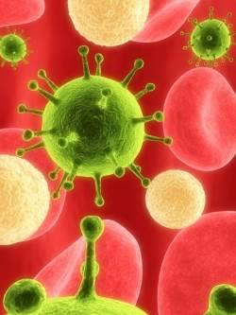
Foods with indigestible fibers that nourish the good bacteria:
- High fiber foods
- Fruits, veggies
- Jerusalem artichokes, onions, kale, Brussels sprouts, banana, berries, nuts
- PRObiotics

These foods contain healthy bacteria like bifodobacteria and lactobacillus.
- Yogurt, Kefir, Kombucha – look for “live or active cultures”
- Fermented foods like: Sauerkraut, Kimchi, Miso soup

Examples of Probiotics and Prebiotics
Class/Component | Source | Potential Benefit
Probiotics
Certain species and strains  of Lactobacilli, Bifidobacteria, Yeast | Certain yogurts, other cultured  dairy products, and non-dairy applications | May improve gastrointestinal health and systemic immunity
Prebiotics
Inulin, Fructo-oligosaccharides (FOS),  Polydextrose, Arabinogalactan,  Polyols—lactulose, lactitol | Whole grains, onions, bananas,  garlic, honey, leeks, artichokes,  fortified foods and beverages,  dietary supplements  and other food applications | May improve gastrointestinal health; may improve calcium absorption
Chart adapted from International Food Information Council Foundation: Media Guide on Food Safety and Nutrition: 2004-2006.

More information at MySmartRD.com

