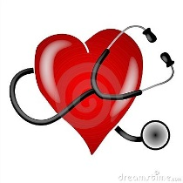
HYPERTENSION (High Blood Pressure)

Summary
About 1 in 3 adults in the U.S. has high blood pressure, or hypertension, but many don't realize it. High blood pressure usually has no warning signs, yet it can lead to life-threatening conditions like heart attack or stroke. The good news is that you can often prevent or treat high blood pressure. Early diagnosis and simple, healthy changes can keep high blood pressure from seriously damaging your health.

What is blood pressure?
Blood pressure is the force of your blood pushing against the walls of your arteries. Each time your heart beats, it pumps blood into the arteries. Your blood pressure is highest when your heart beats, pumping the blood. This is called systolic pressure. When your heart is at rest, between beats, your blood pressure falls. This is called diastolic pressure.

Your blood pressure reading uses these two numbers. Usually the systolic number comes before or above the diastolic number.

How do I know if my blood pressure is high?
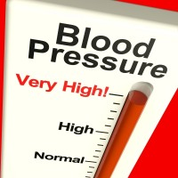
High blood pressure usually has no symptoms. So the only way to find out if you have high blood pressure is to get regular blood pressure checks from your health care provider. Your provider will use a gauge, a stethoscope or electronic sensor, and a blood pressure cuff. For most adults, blood pressure readings will be in one of four categories:

Normal blood pressure less than 120 / 80
Prehypertension 120-139 / 80-89
Stage 1 high blood pressure 140-159 / 90-99
Stage 2 high blood pressure 160 / 100 or higher

People with diabetes or chronic kidney disease should keep their blood pressure below 130 / 80.

Why do I need to worry about prehypertension and high blood pressure?
Prehypertension means you're likely to end up with high blood pressure, unless you take steps to prevent it. When your blood pressure stays high over time, it causes the heart to pump harder and work overtime, possibly leading to serious health problems such as heart attack, stroke, heart failure, and kidney failure.

Who is at risk for high blood pressure?
Anyone can develop high blood pressure, but there are certain factors which can increase your risk:

- Age - Blood pressure tends to rise with age
- Race/Ethnicity - High blood pressure is more common in African American adults
- Weight - People who are overweight or obese are more likely to develop prehypertension or high blood pressure
- Gender - Before age 55, men are more likely than women to develop high blood pressure. After age 55, women are more likely than men to develop it.
- Lifestyle - Certain lifestyle habits can raise your risk for high blood pressure, such as eating too much sodium or not enough potassium, lack of exercise, drinking too much alcohol, and smoking.
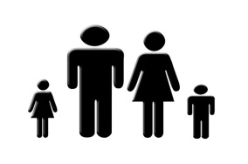
- Family history - A family history of high blood pressure raises the risk of developing prehypertension or high blood pressure

How can I prevent high blood pressure?
You can help prevent high blood pressure by having a healthy lifestyle:

- Eating a healthy diet. To help manage your blood pressure, you should limit the amount of sodium (salt) that you eat, and increase the amount of potassium in your diet. It is also important to eat foods that are lower in fat, as well as plenty of fresh fruit, vegetables, and whole grains. The DASH diet is an example of an eating plan that can help you to lower your blood pressure.

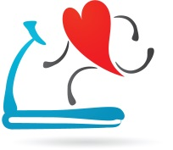
- Getting regular exercise. Exercise can help you maintain a healthy weight and lower your blood pressure. You should try to get moderate-intensity aerobic exercise at least 2 and a half hours per week, or vigorous-intensity aerobic exercise for 1 hour and 15 minutes per week. Aerobic exercise, such as brisk walking, is any exercise in which your heart beats harder and you use more oxygen than usual.

- Being at a healthy weight. Being overweight or obese increases your risk for high blood pressure. Maintaining a healthy weight can help you control high blood pressure and reduce your risk for other health problems.

- Limiting alcohol. Drinking too much alcohol can raise your blood pressure. It also adds extra calories, which may cause weight gain. Men should have no more than 2 drinks per day, and women only 1.

- Not smoking. Cigarette smoking raises your blood pressure and puts you at higher risk for heart attack and stroke. If you do not smoke, do not start. If you do smoke, talk to your health care provider for help in finding the best way for you to quit.

- Managing Stress. Learning how to relax and manage stress can improve your emotional and physical health and lower high blood pressure. Stress management techniques include exercising, listening to music, focusing on something calm or peaceful, and meditating.

If you already have high blood pressure, it is important to prevent it from getting worse or causing complications. You should get regular medical care and follow your prescribed treatment plan. Your plan will include healthy lifestyle habit recommendations and possibly medicines.

Adapted from: https://medlineplus.gov/ More nformation available at MySmartRD.com

