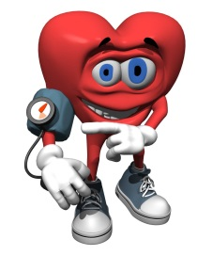
High blood pressure and Weight

Hypertension (high blood pressure) is a common condition that can lead to serious health problems if untreated. Normal blood pressure for most people is no more than 120/80.

Making dietary changes and losing weight are effective treatments for reducing blood pressure. Other lifestyle changes that can help to reduce blood pressure include stopping smoking, reducing stress, reducing alcohol consumption, and exercising regularly. These changes are effective when used alone, but often have the greatest benefit when used together.

DIETARY CHANGES AND BLOOD PRESSURE

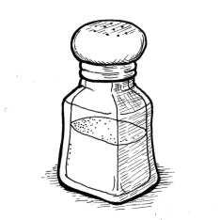
Reduce sodium — The main source of sodium in the diet is the salt contained in packaged and processed foods and in foods from restaurants. Reducing the amount of sodium you consume can lower blood pressure if you have high or borderline high blood pressure.

The body requires a small amount of sodium in the diet. However, most people consume more sodium than they need. A low-sodium diet contains fewer than 2 grams (2,000 milligrams) of sodium each day.

Reduce alcohol — Drinking an excessive amount of alcohol increases your risk of developing high blood pressure. People who have more than two drinks per day have an increased risk of high blood pressure compared to nondrinkers; the risk is greatest when you drink more than five drinks per day.

On the other hand, drinking one (for women) or two (for men) alcoholic beverages per day may benefit the heart in people greater than 40 years old with preexisting high blood pressure.

Eat more fruits and vegetables — Eating a vegetarian diet may reduce high blood pressure and protect against developing high blood pressure. A strict vegetarian diet may not be necessary; eating more fruits and vegetables and low-fat dairy products may also lower blood pressure.

Eat more fiber — Eating extra fiber may decrease blood pressure. The recommended amount of dietary fiber is 20 to 35 grams of fiber per day. Whole grains, legumes, nuts, fruits and vegetables are excellent sources of dietary fiber.

Eat more fish — Eating more fish may help to lower blood pressure, especially when combined with weight loss.

Caffeine — Caffeine may cause a small rise in blood pressure, although this effect is usually temporary. Drinking a moderate amount of caffeine (less than 2 cups of coffee per day) does not increase the risk of high blood pressure in most people.

EXERCISE
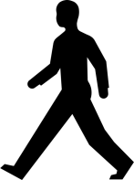
Regular aerobic exercise (walking, running) for 20 to 30 minutes most days of the week can lower your blood pressure. To maintain this benefit, you must continue to exercise; stopping exercise will allow your blood pressure to become high again.

WEIGHT LOSS AND BLOOD PRESSURE
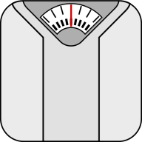
Being overweight or obese increases your risk of having high blood pressure, diabetes, and cardiovascular disease. The definition of overweight and obese are based upon a calculation called body mass index (BMI). You are considered overweight if your BMI is greater than 25, while a person with a BMI of 30 or greater is said to be obese. People who are overweight or obese can benefit from losing weight. Set a goal of keeping your waist in inches at no more than half your height.

To lose weight you must eat fewer calories and exercise more. Fad diets or other diets that are too rigid to continue for long periods of time may promote short-term weight loss, but weight usually returns and even increases when the diet is discontinued. More moderate, permanent changes in lifestyle and eating habits works best for long-term weight control and reducing blood pressure.

WHAT IF I STILL HAVE HIGH BLOOD PRESSURE?
If you continue to have high blood pressure despite making changes in your diet, exercising more, and losing weight, you may need a medication to reduce your blood pressure. Check with your doctor about medications you may need.

Find more information at MySmartRD.com

