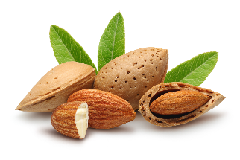
Dietary Fiber

What It Is
Dietary fiber, or fiber, is sometimes referred to as “roughage.” It is a type of carbohydrate found in plant foods and is made up of many sugar molecules linked together. But unlike other carbohydrates (such as starch), dietary fiber is bound together in such a way that it cannot be readily digested in the small intestine.

There are two types of dietary fiber, and most plant foods contain some of each kind:
- Soluble fiber dissolves in water to form a thick gel-like substance in the stomach. It is broken down by bacteria in the large intestine and provides some calories.
- Insoluble fiber does not dissolve in water and passes through the gastrointestinal tract relatively intact and, therefore, is not a source of calories.

Where It Is Found
Soluble fiber is found in a variety of foods, including:
- Beans and peas  - Fruits  - Oats (such as oat bran and oatmeal) | 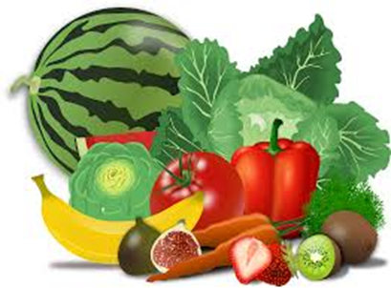  - Nuts and seeds  - Vegetables

Insoluble fiber is found in a variety of foods, including:
- Fruits  - Nuts and seeds  - Vegetables | - Wheat bran  - Whole grain foods (such as brown rice and whole grain breads, cereals, and pasta)
What It Does
- Soluble fiber can interfere with the absorption of dietary fat and cholesterol. This, in turn, can help lower low-density lipoprotein (LDL or “bad”) cholesterol levels in the blood. Soluble fiber also slows digestion and the rate at which carbohydrates and other nutrients are absorbed into the bloodstream. This can help control the level of blood glucose (often referred to as blood sugar) by preventing rapid rises in blood glucose following a meal.
- Insoluble fiber provides “bulk” for stool formation and speeds up the movement of food and waste through the digestive system, which can help prevent constipation.
- Both soluble and insoluble fiber make you feel full, which may help you eat less and stay satisfied longer.

Health Facts
- Most Americans do not get the recommended amount of dietary fiber. Dietary fiber is considered a “nutrient of public health concern” because low intakes are associated with potential health risks.
- Diets higher in dietary fiber promote intestinal regularity and can reduce the risk of developing cardiovascular disease.
- The Dietary Guidelines for Americans recommends consuming a variety of nutrient-dense foods that are good sources of dietary fiber, such as beans and peas, fruits, unsalted nuts and seeds, vegetables, and whole grains. The guidelines also recommend consuming at least half of total grains as whole grains and limiting the intake of refined grains and products made with refined grains.

For Increasing Dietary Fiber in Your Diet
Use the Nutrition Facts Label as your tool for increasing consumption of dietary fiber. The Nutrition Facts Label on food and beverage packages shows the amount in grams (g) and the Percent Daily Value (%DV) of dietary fiber in one serving of the food.

Food manufacturers may voluntarily list the amount in grams (g) per serving of soluble fiber and insoluble fiber on the Nutrition Facts Label (under Dietary Fiber), but they are required to list soluble fiber and/or insoluble fiber if a statement is made on the package labeling about their health effects or the amount (for example, “high” or “low”) contained in the food.

The Daily Value for fiber is 25 g per day. This is based on a 2,000 calorie diet — your Daily Value may be higher or lower depending on your calorie needs.

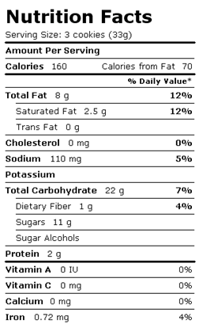
When comparing foods, choose foods with a higher %DV of dietary fiber. The goal is to get 100% of the Daily Value for dietary fiber on most days. And remember:
- 5% DV or less of dietary fiber per serving is low
- 20% DV or more of dietary fiber per serving is high

- Look for whole grains on the ingredient list on a food package. Some examples of whole grain ingredients are: barley, brown rice, buckwheat, bulgur, millet, oatmeal, quinoa, rolled oats, whole grain corn, whole grain sorghum, whole oats, whole rye, and whole wheat.

- Tip: Ingredients are listed in descending order by weight — the closer they are to the beginning of the list, the more of that ingredient is in the food.

- Switch from refined to whole grain versions of commonly consumed foods (such as breads, cereals, pasta, and rice).

- Limit refined grains and products made with refined grains (such as cakes, chips, cookies, and crackers), which can be high in added sugars, saturated fat, and/or sodium and are common sources of excess calories.

- Start your day with a bowl of whole grain breakfast cereal (such as bran or oatmeal) that is high in dietary fiber and low in added sugars. Top your cereal with fruit for sweetness and even more fiber!

- Choose fruit (fresh, frozen, dried, or canned in 100% fruit juice) as snacks, salads, or desserts.

- Keep raw, cut-up vegetables handy for quick snacks — choose colorful dark green, orange, and red vegetables, such as broccoli florets, carrots, and red peppers.

- Add beans (such as garbanzo, kidney, or pinto), lentils, or peas to salads, soups, and side dishes — or serve them as a main dish.

- Try unsalted nuts and seeds in place of some meats and poultry.

